**CS-335 Database Systems**

**evaluate-HU**

**Project Final Report Submission**

**Team:** AAS

**Team Members:** Salman Younus, Anand Kumar, Syed Anus Ali.

**Introduction:**

The present course evaluation process at Habib University is tedious and unreasonably complex. Currently, it forces the students to go through a list of courses offered in that semester and fill in the evaluations for the courses they are enrolled in that semester.   
The objective of this project is to allow the students to effortlessly complete their course and professor evaluations. We have done this by developing a web-based platform. This platform serves two purposes for the students; allow them to complete their course/professor evaluations and read anonymized reviews of past courses/professors.  
The platform maintains a database that will store the semester-wise enrolment data of the students i.e. the courses each student is enrolled in the ongoing and previous semesters.

**Business Scenario:**

The end of term evaluation process at Habib University involves a process which requires students to go through and pick the courses that they were enrolled in order to review them. This process is done via learning management system where a list is provided for all courses offered in the semester.

The course/instructor evaluation is carried on in the following steps:

1. The evaluations are opened on LMS where students get to go through the list and pick up the courses.
2. The students review their courses in a given timeslot.
3. The University administration collects these reviews and then send these to the relevant professors.

Prior to enrolment and during the same time as evaluations take place, students generally reach out to the senior students to get their reviews on different professors and the courses that they offered.   
The platforms that they use to get the reviews include:

1. Personal messaging.
2. Social media posts.

**evaluate-HU:**

The two scenarios described above represents an evaluation recording system that can be integrated and modified in the way that they are done. evaluate.HU provides a single platform with a data on all of the past and present offerings.

The platform performs the following functionality:

1. Provides a profile for students to access the courses and faculty members that they need to review rather than providing an entire list of all course offerings and faculty of those courses.
2. Allow the Professors to directly receive student's reviews and view the past reviews.
3. An Admin access to add new students, faculty members and sections to the database and also retrieve data about any student’s evaluation.

**Final ERD:**

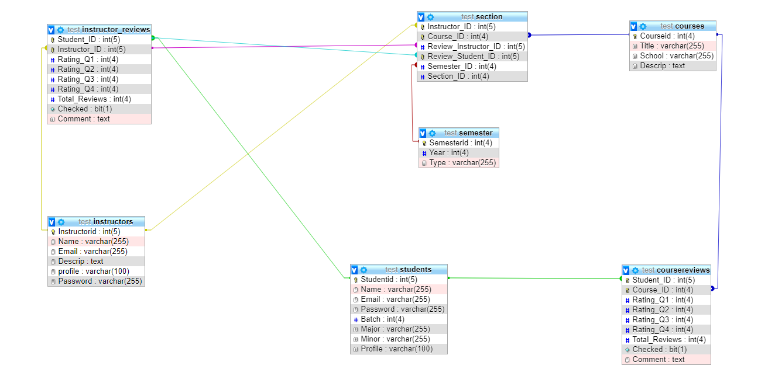

**Functions/Modules:**

Login:

The login module allows the user to enter their email address, password and select which portal the user wants to access, i.e instructor, student or RO. The backend verifies the email address and password with the portal the user wants to access and logs in or gives an error accordingly.

Student Portal:

* Home Page

The home page of the student portal allows the student to select and review the courses and instructors depending on the courses he/she is enrolled in with which professor.

* ­ Review Submit Form

This form opens up when the student wants to review a course he/she is enrolled in or review a professor if the student is enrolled in a course taught by them. This form contains four specific, multiple choice, questions and a comment box. The filled form is then added to the appropriate table in the database.

* Course Search

This module allows the student to search for a specific course.

* Course Profile

This page is loaded after the student successfully searches for a course. This page shows the comments given and the average ratings of the four multiple choice questions answered by all the previous evaluators. This page also includes a brief course description.

* Instructor Search

This module allows the student to search for a specific instructor.

* Instructor Profile

This page is loaded after the student successfully searches for an instructor. This module includes a picture and a short description of the instructor. This page also shows the average ratings of the four multiple choice questions and comments given by all previous evaluators.

RO Portal:

* Add Student

This module allows the RO user to add a student into the database.

* Add Faculty

This module allows the RO user to add an instructor into the database.

* Add Enrollments

This module allows the RO user to add a course and an instructor in a student’s “To be reviewed courses” list for the current semester.

* Students Reviews

This module allows the RO user to retrieve all reviews made by a particular student.

Instructor Portal

* Home Page

The home page is pretty similar to the instructor profile in the student portal. This page shows the average of each of the four multiple choice answered by students in evaluation forms and anonymized comments by students as well.

**GUI and Test Cases:**

Login Page: Main login page for student, faculty and admin (RO):

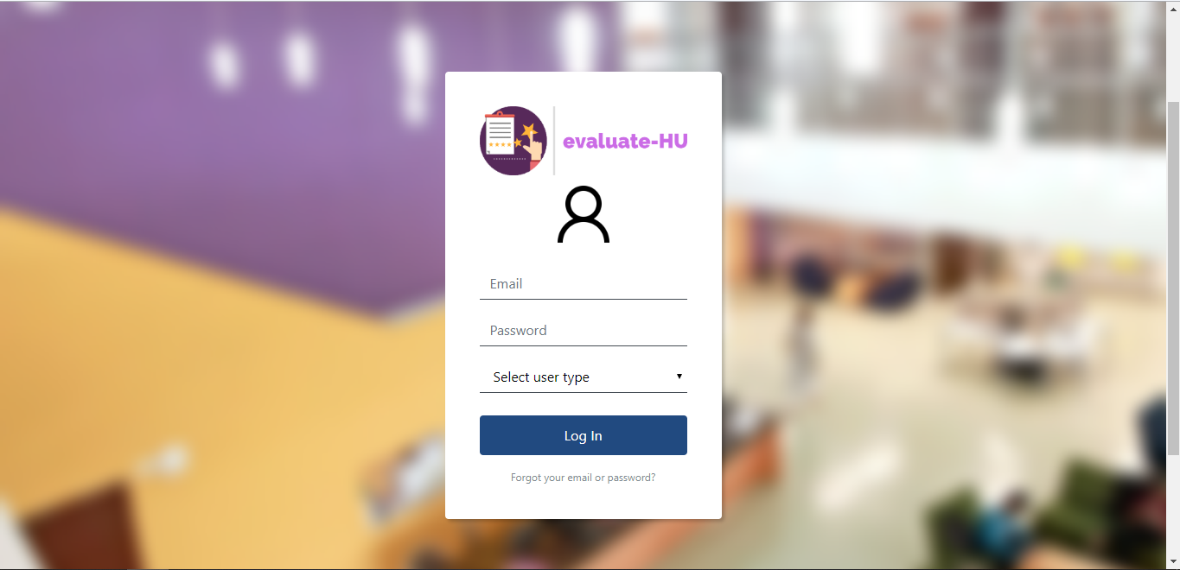

Student Login:

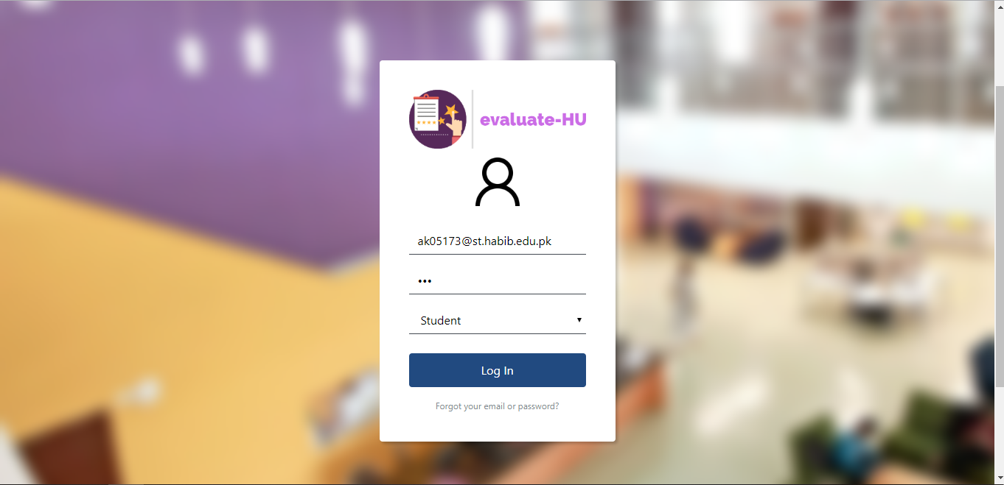

Student Profile:

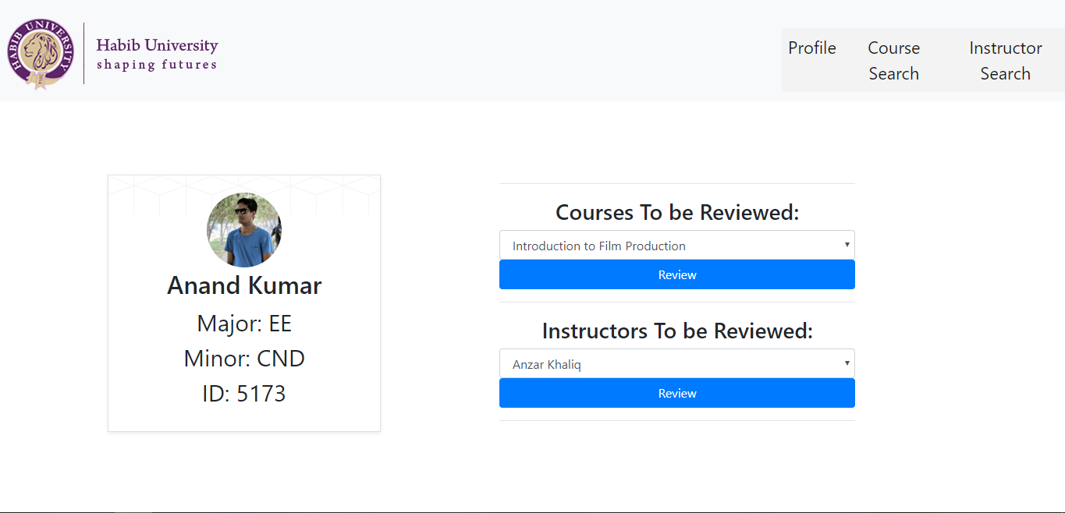

Instructor Login:

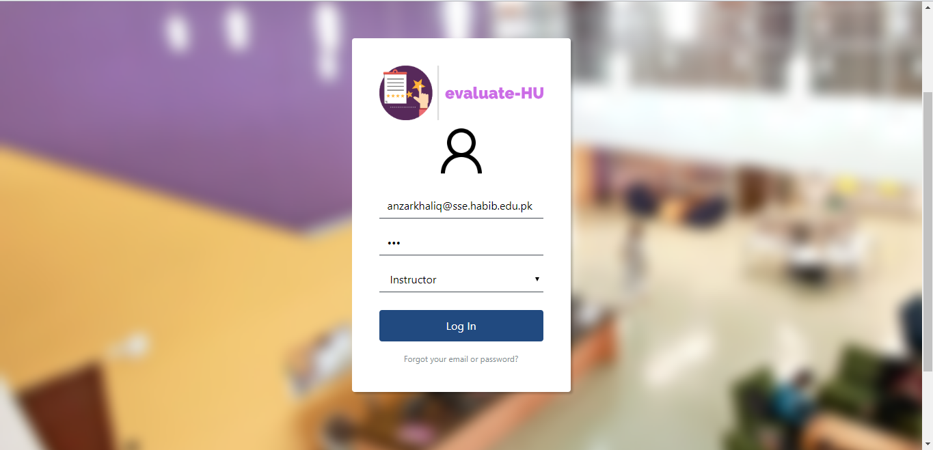

Instructor Profile:

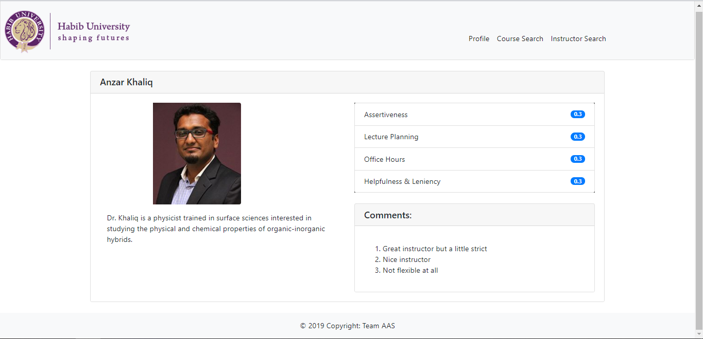

Instructor Search Page:

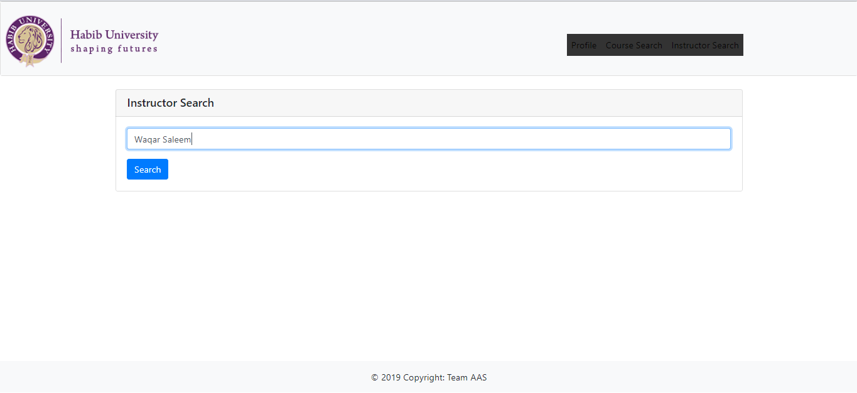

Course Search Page:

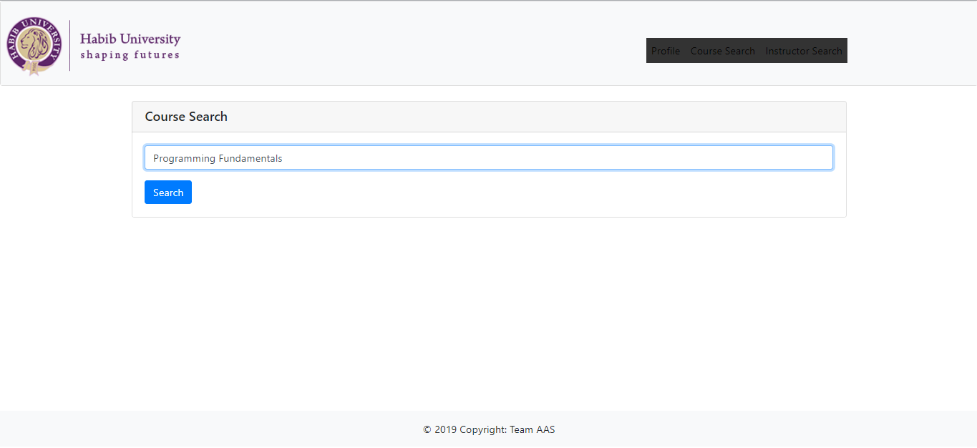

Admin Login:

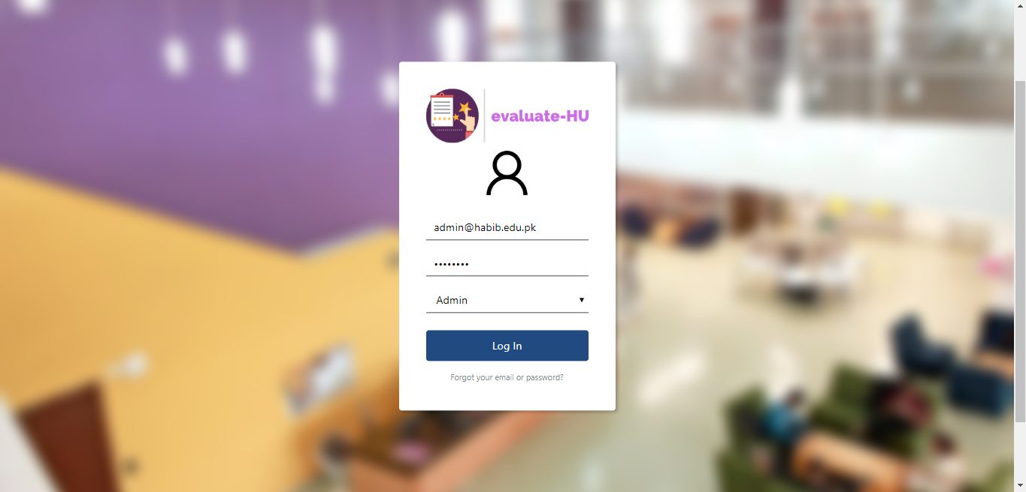

Admin Page: To add students and faculty to database.

